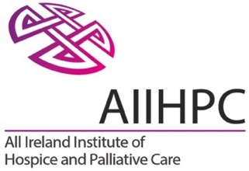

Public Awareness Campaign

DRAFT 2.1

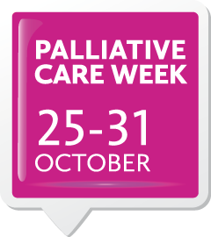

Report on Public Awareness Raising
Palliative Care Week 2015, October 25-31

Prepared by Ronan Cavanagh, Cavanagh Communications and Cathleen Mulholland, Programme Manager Policy and Practice, AIIHPC.

Contents

Contents 2
Summary 3
Top line Outcomes 3
1. Campaign Context 2015 4
2. Campaign Overview 5
Objectives 5
Audiences 5
Reference Group 5
Key Messages 6
3. Campaign Development 7
Resourcing 7
Communications Consultant 7
Design 7
Database 7
Information Materials 7
Media 7
Website 8
Social Media 8
Events 8
Costs 8
4. Campaign Impact 9
Information Materials 9
Media Profile 9
Website 9
Social Media 9
Events 9
Commentary 10
Appendices 12
Appendix A: Information Materials 12
Appendix B: Media Coverage 15
PRINT 15
RADIO 15
ONLINE 15
WEBSITES 15
Appendix C: News Releases 16

Summary

All Ireland Institute of Hospice and Palliative Care (AIIHPC) ran the second ever dedicated campaign, to raise greater public awareness and understanding of palliative care, across the island of Ireland from 25-31 October 2015.

The campaign was developed with guidance and input from a Campaign Reference Group that was representative of the sector across the Republic of Ireland and Northern Ireland.

Due to budget restraints and a period of change at the Institute, the 2015 campaign was significantly smaller than the 2014 campaign. There was a shorter lead in time and the budget level significantly less.

Given the reduced scale of the campaign, key deliverables were focused on which would best return positive and tangible outcomes.

Top line Outcomes

- The campaign Key Messages and supporting materials were very well received and supported across the sector
- 19 newspaper articles were published, 9 radio interviews broadcast and 10 articles published online
- A broad range of information events were held onsite by service providers across the island
- Twitter activity increased achieving 19,000 impressions and 376 engagements
- There were 3,600 page views and 1,200 unique users on the campaign website pages at www.palliativecareweek.com
- The goodwill and support built up by the campaign in 2014 was maintained and secured for future campaigns.

Palliative Care Week 2015 was delivered for a cost of €13,400 / £9,600, exc. of VAT. (€16,500 / £11,800 inc VAT @ 23%)

1. Campaign Context 2015

In 2015, AIIHPC set out to deliver outputs on raising public awareness of palliative care by coordinating a second all-island Palliative Care Week.

The campaign followed a successful first all-island public awareness campaign in October 2014.

In 2014, there had been a budget of €104,000 / £75,000 (including significant advertising) to deliver the campaign and development began early in the year. A comprehensive series of planning, development and engagement meetings took place with key partners in the sector leading up to the campaign.

During 2015 the Institute was nearing the end of its five year work programme 2011-2015 and it was not certain if Palliative Care Week would take place, largely due to budget constraints. A decision to run Palliative Care Week 2015 was reached in August 2015.

The 2015 campaign would run on a smaller scale, but it was agreed that running it would best serve the long term goal to secure wider partner funding in future years.

In 2014, the campaign had taken place in early October to coincide with World Hospice Week. However, in 2015 this was not possible as the Institute was preparing to host a Global Colloquium in Palliative Care in mid-October. It was therefore held during the last week of October.

The budget for 2015 was €16,500 / £13,800 (from €104,000 / £75,000 in 2014) and there was no advertising budget, which had been a major part of the 2014 campaign. The campaign focused on less cost intensive deliverables such as messaging and visuals, media profiling, social media and engagement with the sector.

2. Campaign Overview

Objectives

The objectives for Palliative Care Week 2015 were to:

- Challenge the myths and limitations in public awareness and understanding of palliative care, and advance a new and broader public debate and understanding
- Use the activities as an opportunity to progress deeper relationships and joined up working across the sector
- Maintain Palliative Care Week as an important event in the sector with a view to securing partner funding in future years.

Audiences

- The primary audience was the general public and community in the Republic of Ireland and Northern Ireland.
- Secondary audiences included politicians, policy makers, health agencies, health professionals, service users and opinion leaders.

Reference Group

To develop and agree the Key Messages, AIIHPC established a Reference Group which was representative of the sector North and South. The Terms of Reference for the Group were to advise on a campaign which:

- Identifies messages and content which are representative of thinking and issues across the sector
- Is reflective of patient perspectives
- Integrates harmoniously with messages and activities of other stakeholders across the sector.

Those invited to join the Reference Group included:

- Anne Cooney, Chief Executive Southern Area Hospice Services, NI
- Niamh Finucane, Chair of IAPC Board, ROI
- Sharon Foley, (Chief Executive Irish Hospice Foundation) or nominee - AIIHPC Policy and Practice Steering Committee ROI
- Eithne Frost (Voices4Care member) - AIIHPC Management Committee, ROI
- Fiona Gilligan (Director of Communications, SafeFood) or nominee - AIIHPC Policy and Practice Steering Committee
- Corrina Grimes, AHP Consultant, Public Health Agency, NI
- Maeve Hully, CEO of NI Patient and Client Council, NI
- Dr Kiran Kaur, Consultant in Palliative Medicine, Northern Ireland Hospice and Belfast Trust, NI
- Sarah McCloskey, Chief Executive Marymount Hospice, Cork, ROI
- Professor Sonja McIlfatrick, Professor of Nursing, University of Ulster NI
- Dr Paul McIvor, (Medical Director Foyle Hospice) - AIIHPC Policy and Practice Steering Committee NI
- Megan Perry, Communications Officer, Public Health Agency, NI
- Dr. Karen Ryan, (Palliative Care Consultant St Francis Hospice, Clinical Lead for Palliative Care HSE) - AIIHPC Management Committee, ROI
- Sheilagh Reaper-Reynolds, General Manager Palliative Care, Health Service Executive, ROI
- Hazel Smullen, (Education and Practice Development Co-ordinator, North West Hospice, Sligo) - AIIHPC Policy and Practice Steering Committee ROI
- Ger Tracey, Clinical Operations Manager, Blackrock Hospice, ROI.
Engagement with the group included email circulars and phone conversations at two critical points including:

- Feedback on first set of campaign Key Messages and Design proofs
- Feedback on revised / second set of campaign Key Messages and Design Proofs.

Furthermore, AIIHPC’s Policy and Practice Steering Committee were informed about the developments of the public awareness work and provided valuable feedback.

Key Messages

Following consultation with the Reference Group, the Key Messages agreed for the campaign were:

A Palliative Care Approach....

- Can be provided in many different settings – at home, in a nursing home, in hospital, or in a hospice – depending on each person’s needs and preferences
- Aims to achieve the best possible quality of life for people with serious illness
- Is beneficial for anyone with a non-curable illness, regardless of age or condition
- May be suitable for a number of years, not just the weeks and days at the end of life
- Supports family, friends and carers both during an illness and afterwards.

Find out more...

- Palliative Care Week takes place from October 25-31 across the Republic of Ireland and Northern Ireland
- Go to www.palliativecareweek.com
- Talk with others - your health and social care professionals.

3. Campaign Development

Resourcing

Communications Consultant

AIIHPC recruited Communications Consultant, Ronan Cavanagh of Cavanagh Communications, to lead on Palliative Care Week, working initially with AIIHPC Director Paddie Blaney and during the campaign with AIIHPC Policy and Practice Programme Manager, Cathleen Mulholland.

Ronan was already in situ working with the Institute as their Communications Consultant and had previously worked on Palliative Care Week 2014.

Design

Dublin based agency Publicis Engage, worked on the concepts, design and production of the printed and online materials for Palliative Care Week 2015. Again Publicis Engage had worked on the 2014 campaign.

Database Development

To develop the campaign reach, the Email database was expanded from 300 in 2014 to 1,400 recipients and the hardcopy database was expanded from 140 recipients to 240.

Information Materials

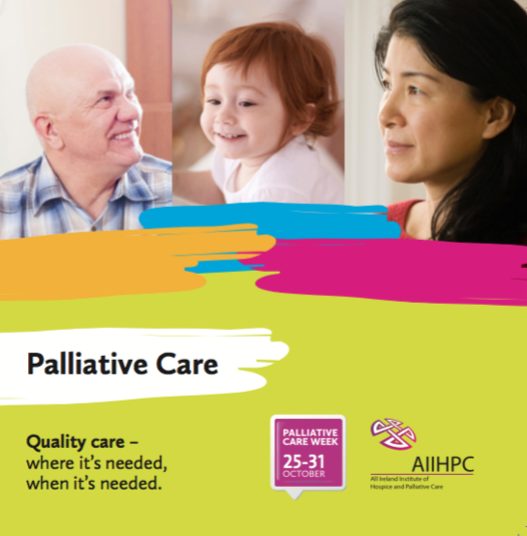
Approximately 1,500 campaign Information Packs were distributed. The Packs included:

- A Document Folder
- An Information Leaflets
- Posters (A3 & A4)
- A Communications Toolkit

Four ‘Campaign Briefing’ emails were issued to the database.

See the campaign information materials in Appendix A, or they can be viewed at www.palliativecareweek.com.

Media

Two news releases were developed for issue to all relevant media - print, radio, TV and online.

The first press release included a call to action for the public and sector to engage with the campaign. The second press release re-iterated the call to action and also launched the Palliative Hub – Adult which went live during Palliative Care Week.

The Public Health Agency in Northern Ireland (PHA) helped with distribution of the press materials in Northern Ireland. Both Our Lady’s Hospice and Care Services and Northern Ireland Hospice assisted with providing high quality case studies for interviews.

See the news releases in Appendix C.

Website

The website pages at www.palliativecareweek.com were updated to include new content and messaging for the 2015 campaign with all of the materials downloadable. Videos, useful definitions, go to points for information and services, and links were also included.

Social Media

All campaign materials and activity promoted use of the hashtag #pallcareweek. Regular Tweets were issued in the lead into and during the campaign. Also recommended Tweets were circulated to the campaign database in the Communications Toolkit.

Events

Through the email briefings which were issued, stakeholders were encouraged to hold information events during the week and and place the posters and leaflets on public display. Many queries were received, from all corners of the country, and a range of information events were held.

Costs

The total campaign cost for 2015 was €13,400 / £9,600, exclusive of VAT @23% broken down into:
- Creative Concepts, Design, Production and Print = €7,900
- Postage = 1,200
- Communications Consultant = 4,300

Additional time and support was provided by AIIHPC staff and this was absorbed within their ongoing running costs.

(Costs inclusive of VAT were €16,500 / £11,800)

4. Campaign Impact

Given the smaller scale of the 2015 campaign, it was decided not to again carry out an Omnibus post campaign survey, due to the proportionately high cost of doing so and because it would not provide a parallel comparison with 2014.

Therefore, measuring the impact and outcomes of the campaign is based upon desk gathered information and is indicative.

Information Materials
- The campaign Key Messages and Designs were well received and supported across the sector. In particular, the tone and graphics used were universally received warmly.

Media Profile
- 19 newspaper articles were published, 9 radio interviews broadcast and 10 articles published online (See Appendix B)
- There was less media coverage than 2014, particularly in Northern Ireland.
- However, there was a greater amount of high quality national feature coverage in both the RoI and NI (Irish Times & Belfast Telegraph features and Newstalk and Downtown radio panel interviews). This coverage was discursive and of high value.

Website
There were 3,600 campaign website pages viewed at www.palliativecareweek.com during the period of the campaign. The key statistics are:

- 3,600 webpages viewed
- 1,600 visits
- 1,200 unique users

- 59% from RoI
- 27% from UK
- 4% from USA.

Social Media
There were 19,000 impressions on Twitter related to Palliative Care Week and 376 engagements (re-tweets, follows, favourites etc) which was an increase on 2014.

Events
Each organisation / site on the database was encouraged to hold information events and was sent the hardcopy information materials. Some came back to discuss and confirm activities, but many didn’t.

It is therefore not possible to definitively list activities which took place during the week. Following is a ‘known’ list, but is likely to be an overall underestimate.

Known events and activities include:

- HSE (link to campaign landing page run from HSE website homepage)
- Irish Cancer Society (supportive news release issued)
- Irish Hospice Foundation (poster and leaflets displayed)
- Jack and Jill Foundation (supportive news release issued)
- Milford Care Centre (posters and leaflets displayed, information events held)
- Northern Ireland Hospice (posters and leaflets displayed)
- PHA (internal circular issued to Communications Leads in the NI Health and Social Care Trusts and link to campaign landing page run from the PHA website homepage)
- Portiuncula Hospital (posters and leaflets displayed, information events held)
- St. James’s Hospital (posters and leaflets displayed, information events held)
- Rotunda Hospital (posters and leaflets displayed, information events held)
- Northern Health and Social Care Trusts (posters, leaflets, information events and media interviews)

www.hse.ie
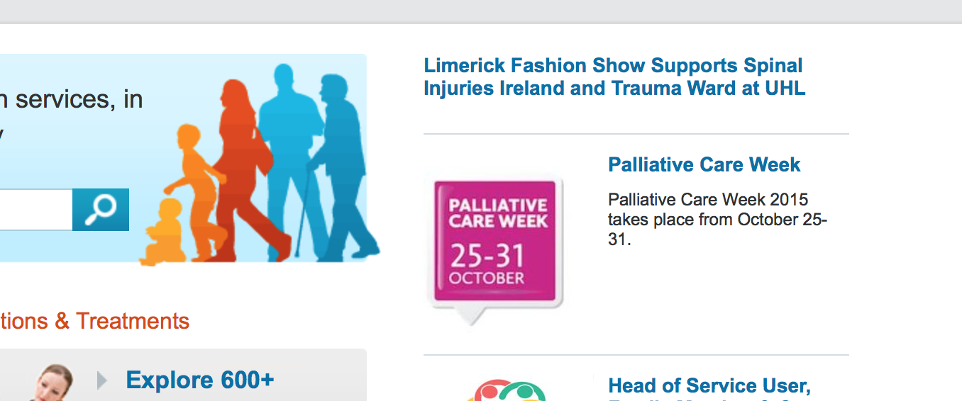

www.publichealth.hscni.net.

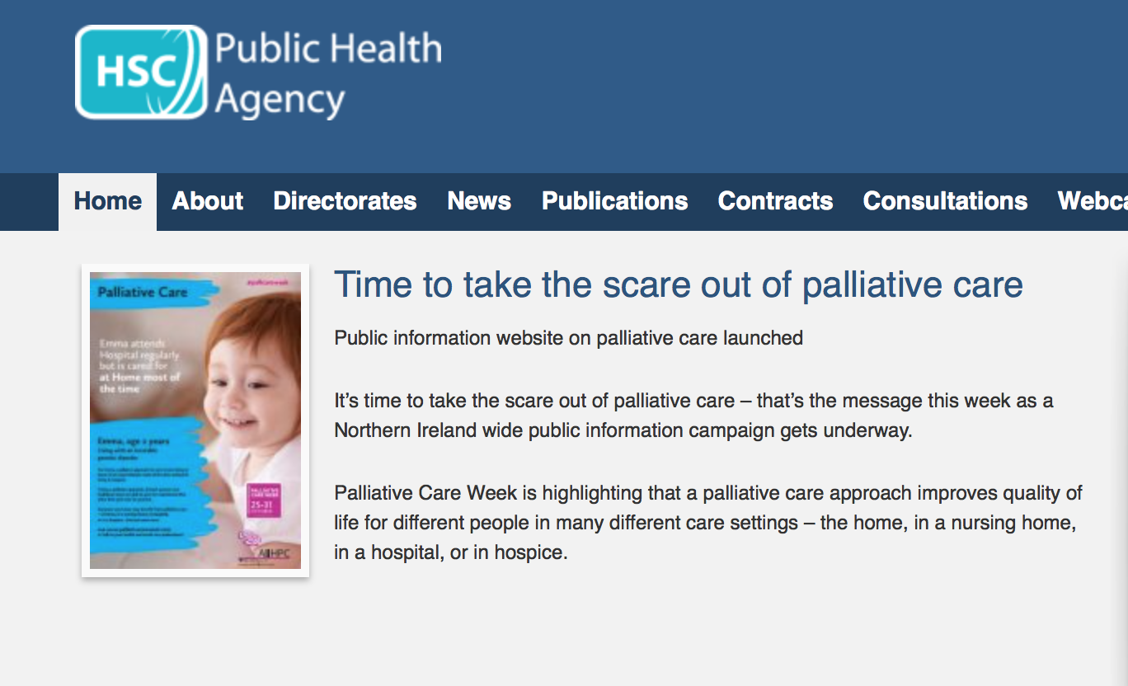

Commentary

Given the shorter timeframe and much reduced budget, Palliative Care Week 2015 is deemed to have been successful at achieving its core objectives of 1) raising awareness of Key Messages among the public 2) building engagement with the sector and 3) maintaining continuity for the Week as an active event in the sector.

There were learnings from the 2015 campaign for consideration in future years and these are as follows:

- A six month lead in time is ideal to develop messaging, build support and engage with stakeholders
- An Institute-wide campaign working group is worthwhile to support campaign planning and development
- Integrating the campaign messaging with public research, which the Institute is involved in, is of benefit to campaign content and media profiling
- Advertising, particularly on local radio, adds significantly to the reach of the campaign
- Engaging and meeting with the major stakeholders in advance (HSE, PHA, Departments of Health and the major service providers) is very worthwhile.
- Numerous organisations favoured holding future Weeks in sync with World Hospice Week (generally the first week in October), which makes good sense
- Many contacts in the sector work part-time, or week on week off, so circulating the campaign printed materials three to four weeks in advance was flagged by stakeholders
- Invest effort in social media activity, as the sector is highly active on it
- For clarity all web traffic could be directed to one address – www.thepalliativehub.com – with a tab to the specific public awareness pages there. (However, continue to use www.palliativecareweek.com and #pallcareweek)
- Integrating media case studies, through services providers, helps with achieving high value feature media articles and interviews

Appendices

Appendix A: Information Materials

The Campaign Information Materials can be downloaded and viewed in full quality at www.palliativecareweek.com

INFORMATION LEAFLET
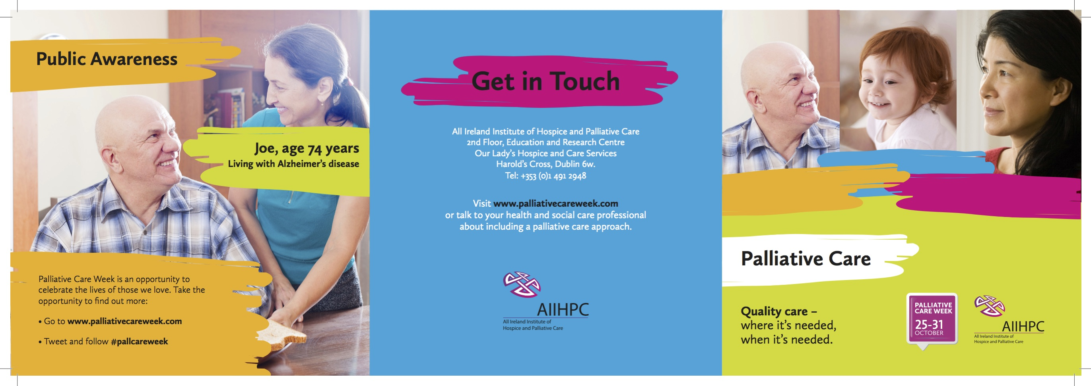
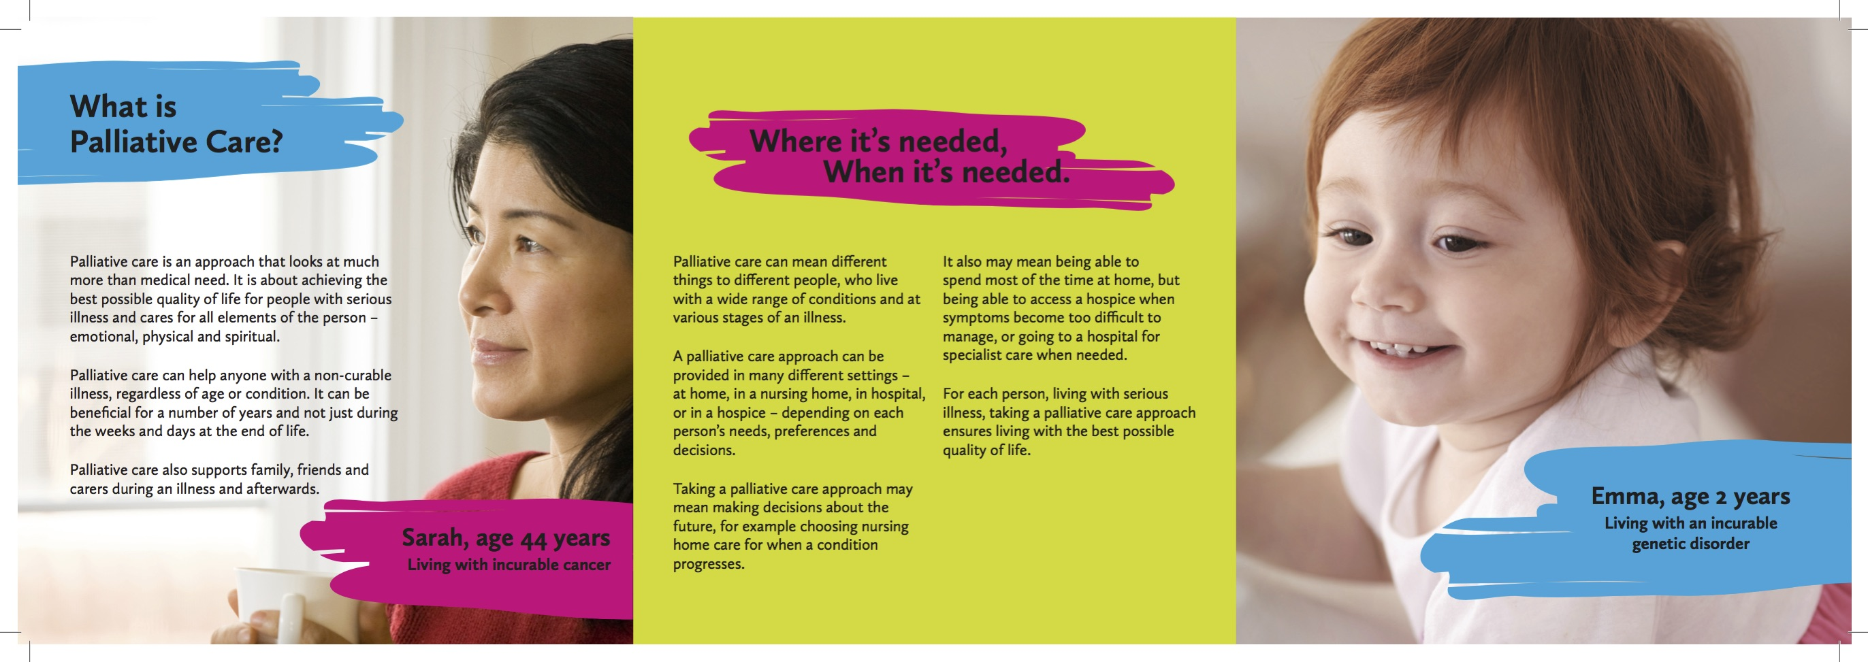

POSTERS
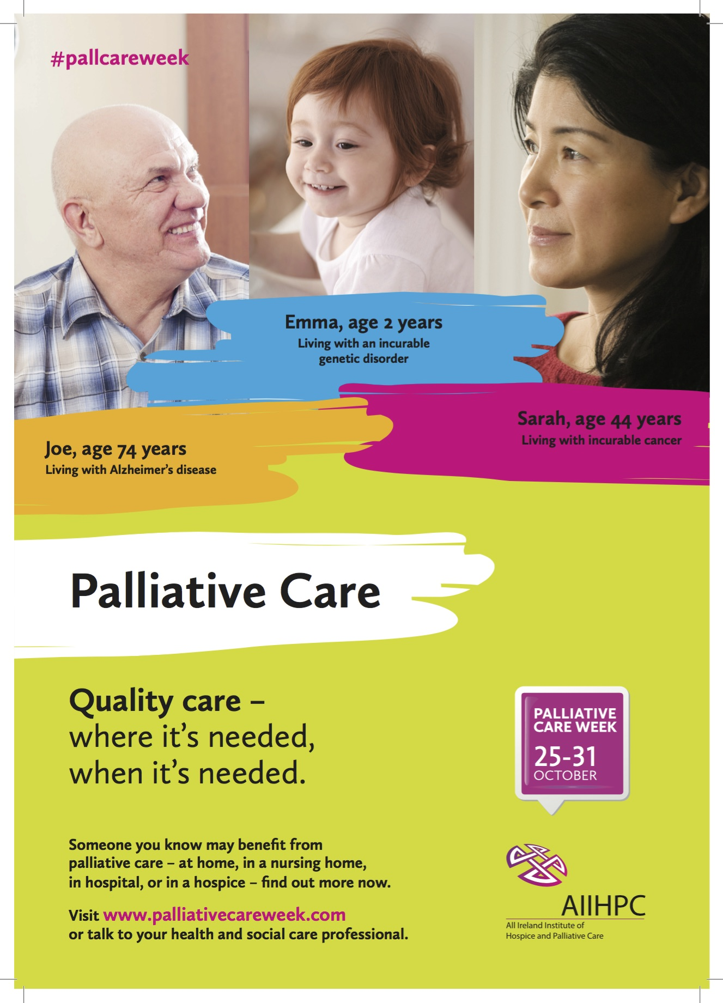

COMMUNICATIONS TOOLKIT

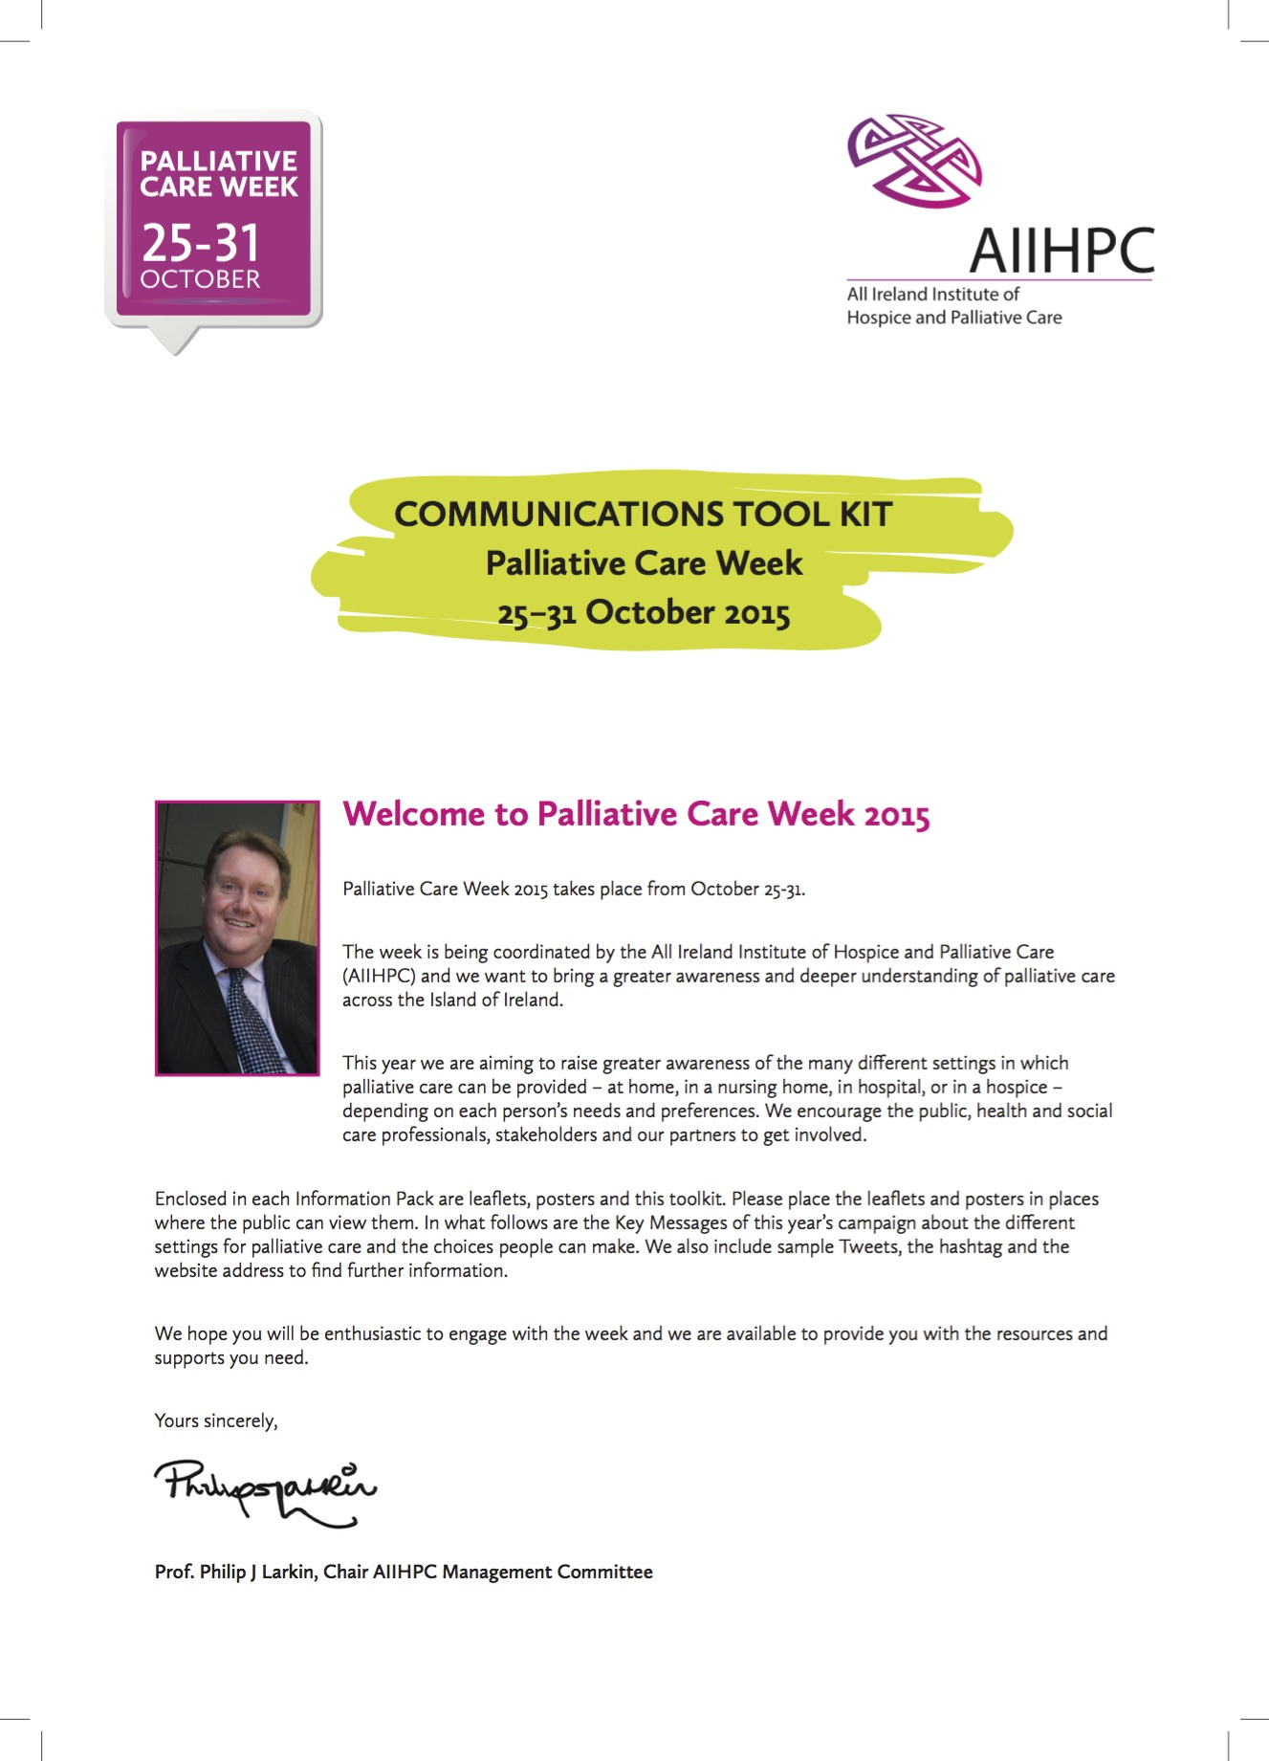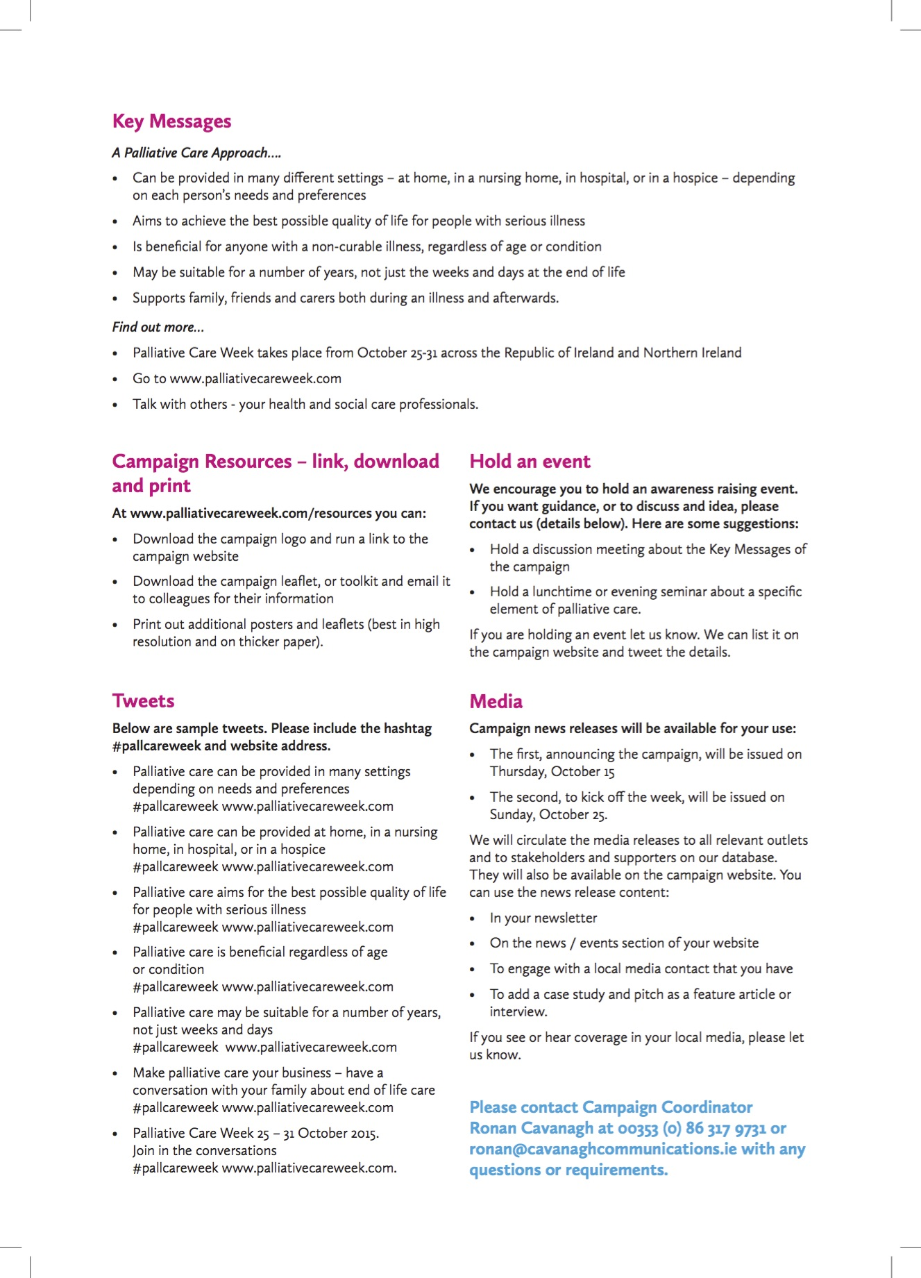

FOLDERS

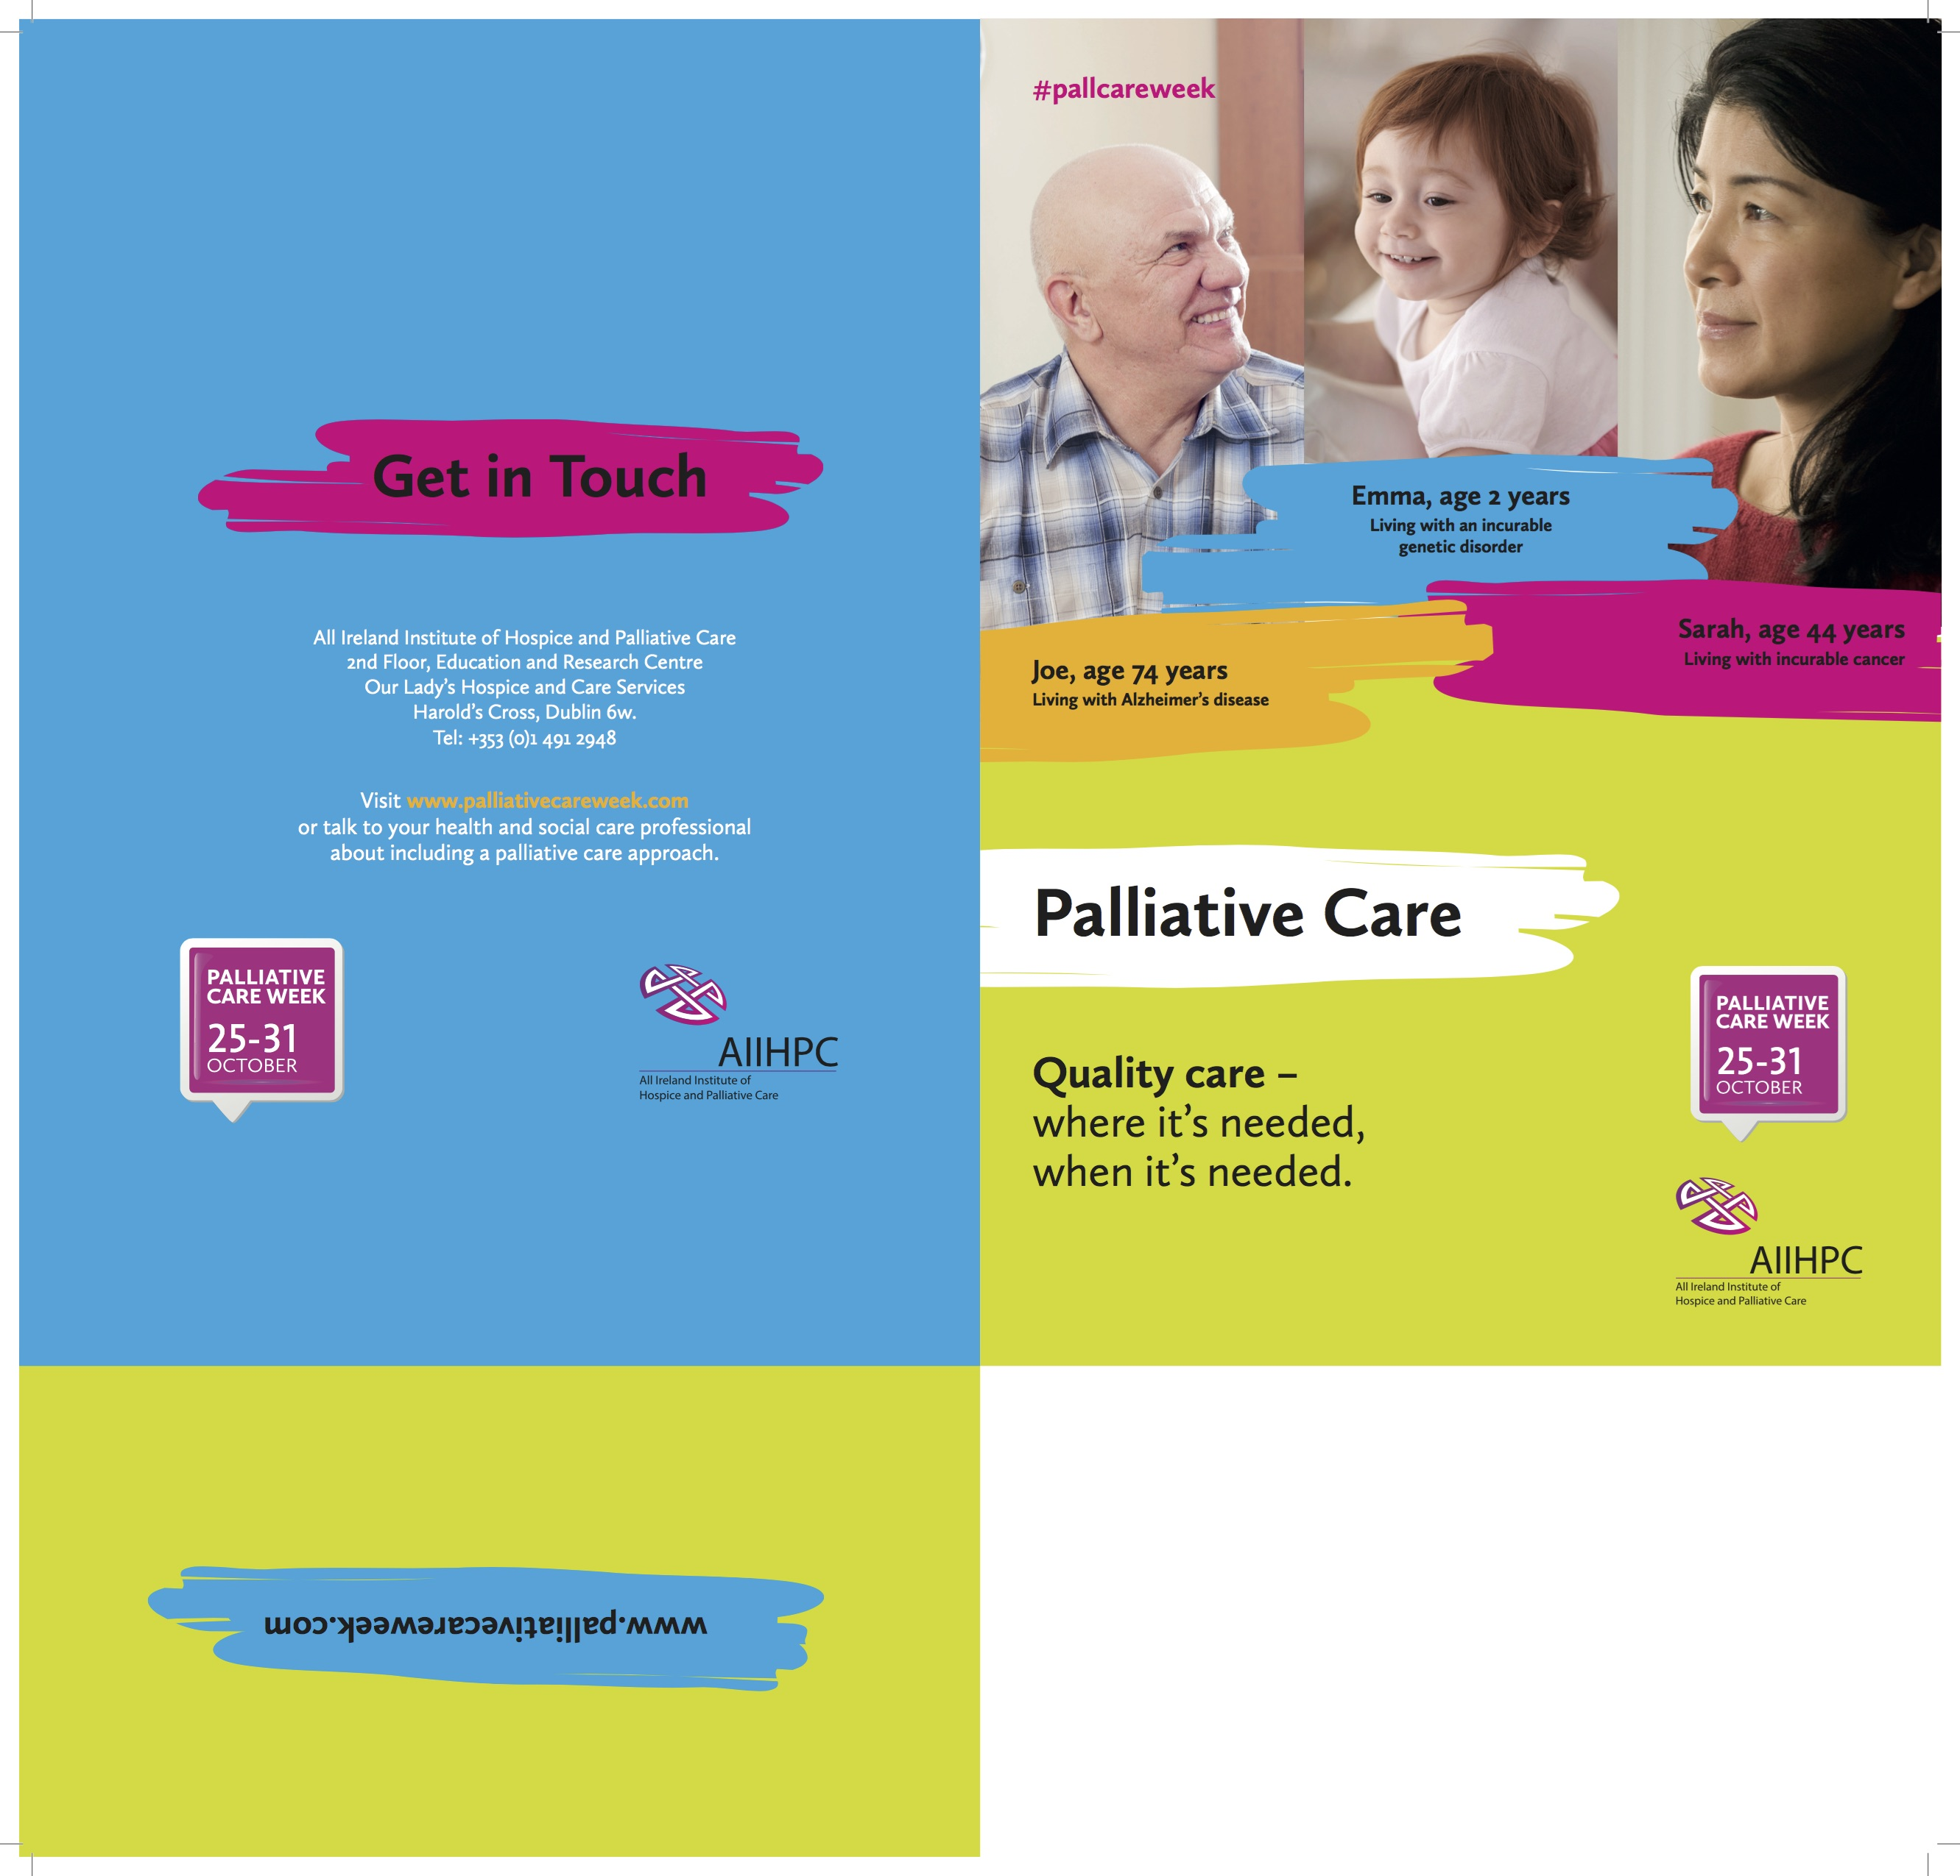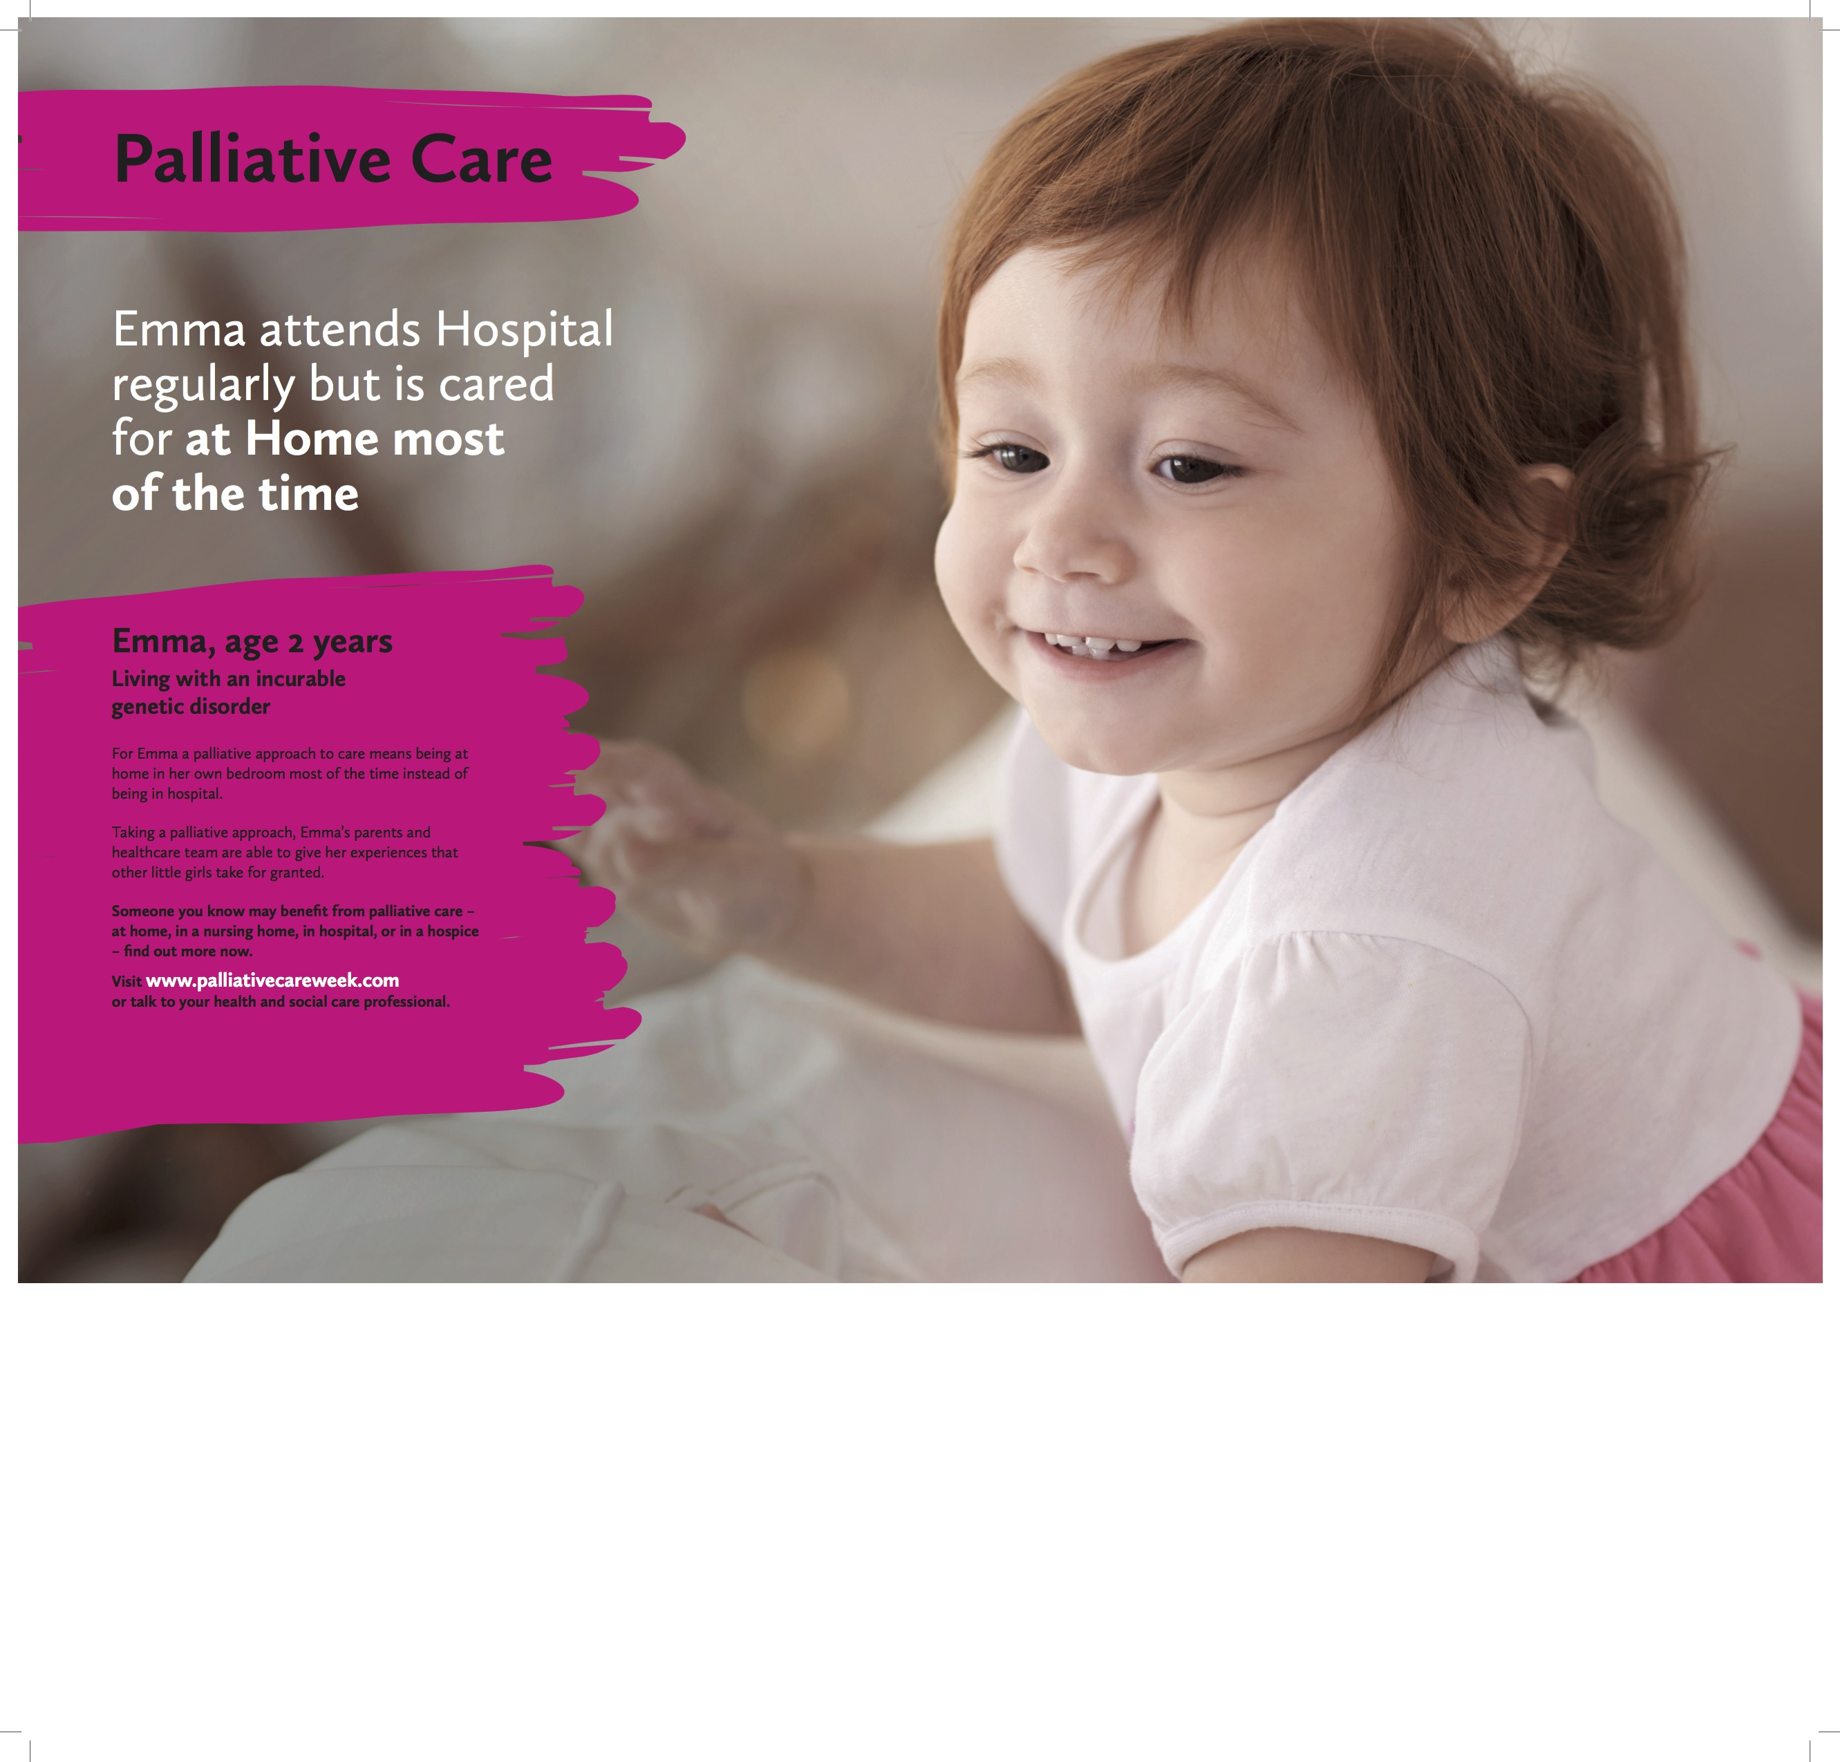

VIGNETTE STORIES (only in download)

Joe Emma
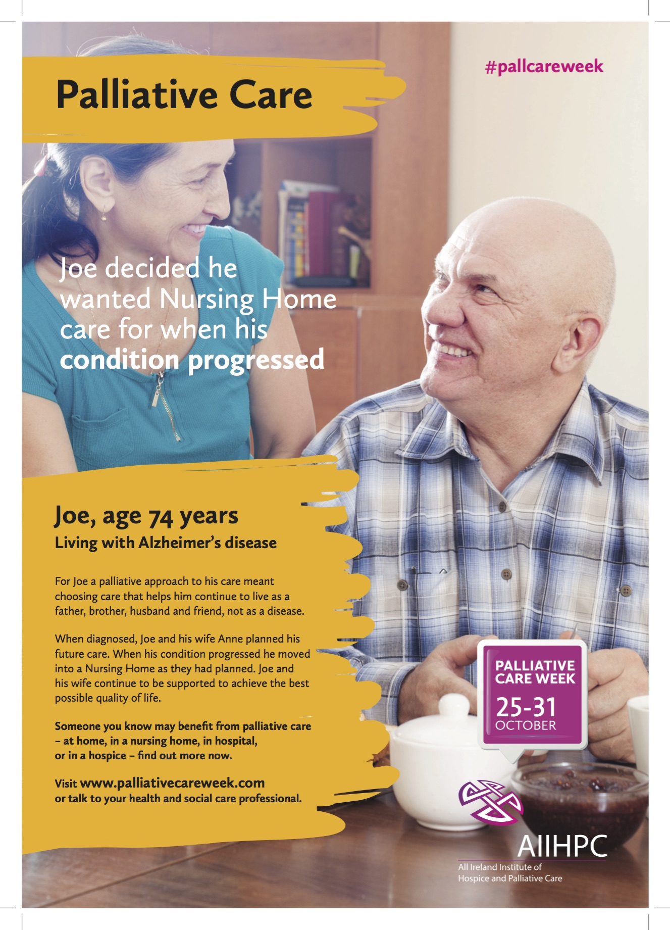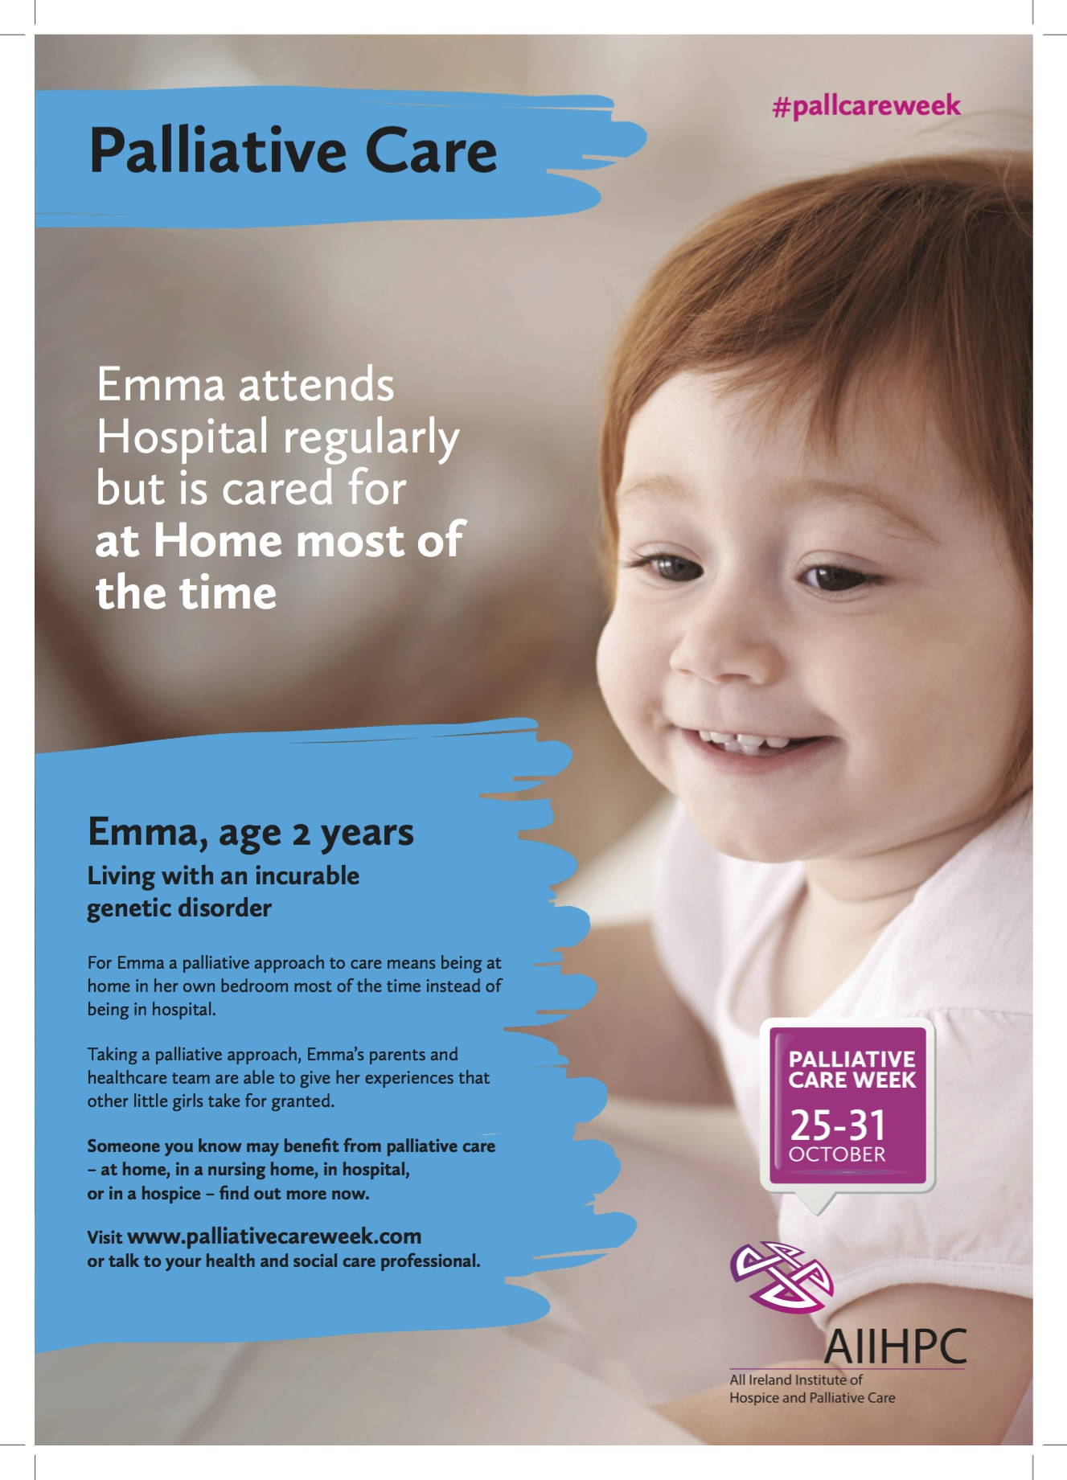

Sarah
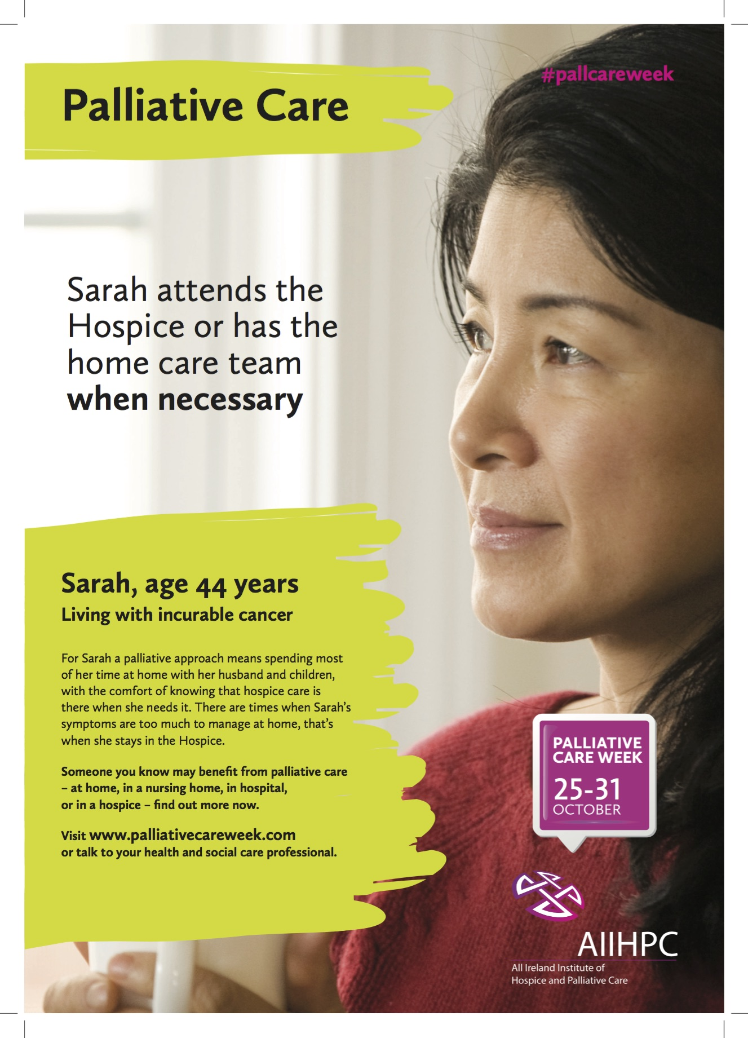

Appendix B: Media Coverage

PRINT

National

RoI
- Irish Times, Health Supplement
- Irish Independent, Health Supplement
- Irish Independent
- Irish Mirror
- Irish Mirror
- Medical Independent

NI
- Belfast Telegraph

Local

- Donegal Post
- Dublin Southside People
- Kerry’s Eye
- Limerick Leader
- Limerick Post #1
- Limerick Post #2
- Northern Standard
- Southern Star
- Vale Star #1
- Vale Star #2
- Weekly Observer #1
- Weekly Observer #2

RADIO

RoI
- Newstalk breakfast with Ivan Yeats
- Castlebar Community Radio
- Highland Radio
- Tipp Mid West
- Roscommon FM
- South East Radio
- Waterford Local Radio

NI
- Downtown / CoolFM
- Onair.com with David Hunter

ONLINE

- Irish Times
- Irish Times, Health Supplement
- Irish Independent
- Irish Independent, Health Supplement
- Londonderry Sentinal
- Irishhealth.com
- Activelink
- eHospice

WEBSITES

- HSE website homepage
- PHA website homepage.

Appendix C: News Releases

Release 1 - RoI Version

Issued by the All Ireland Institute of Hospice and Palliative Care
Thursday, October 15, 2015

Palliative Care beneficial in many settings – the home, nursing home, hospital or hospice

Palliative care approach encouraged in both community and healthcare settings

A public information campaign to highlight the benefits of a palliative care approach, both in community and healthcare settings, has been launched across the country.

Palliative Care Week 2015 is being coordinated by the All Ireland Institute of Hospice and Palliative Care (AIIHPC) and takes place from October 25-31.

The campaign follows a recent AIIHPC survey which found that 68% of people with an incurable illness wanted to plan for the future of their care. It also found that people wanted more timely and appropriate information and better emotional and psychological care.

The key message for Palliative Care Week is that a palliative approach to care can be provided in many different care settings – at home, in a nursing home, in a hospital, or in a hospice – depending on each person’s needs, preferences and decisions.

Institute Director Paddie Blaney urged people’s understanding to move away from a perception that palliative care is only about a person’s final weeks and days in a hospital or hospice.

“A palliative care approach cares for all elements of a person with a serious or non-curable illness – emotional, physical and spiritual. Taking this approach early on can mean being able to experience the best possible quality of life for longer.”

“It may mean being able to spend most of the time at home and accessing hospice care when symptoms become too difficult to manage, or going in and out of hospital for specialist care when needed, or receiving quality of life care in a nursing home. We encourage patients, families and carers to talk with their health and social care professionals about having a palliative care approach included as part of planning their care.”

The awareness drive is being widely supported by health and social care services in both the Republic of Ireland and Northern Ireland.

The campaign is also being supported by Voices4Care member and patient advocate Eithne Frost who said: “For each person, living with serious illness, taking a palliative care approach ensures living with the best possible quality of life at each stage of an illness.”

The campaign is being supported by providers of hospice and palliative care across the Republic of Ireland and Northern Ireland. Many information events will take place across both jurisdictions during Palliative Care Week. More information will be at www.palliativecareweek.com

Further Information
Ronan Cavanagh, Cavanagh Communications: 00353 (0) 86 317 9731 / Twitter: #pallcareweek

NOTES to the Editor

AIIHPC
The All Ireland Institute of Hospice and Palliative Care (AIIHPC) aims to improve end-of-life care and experience on the island of Ireland by enhancing capacity, developing knowledge, promoting learning, influencing policy and shaping practice. AIIHPC is comprised of a consortium of Health Agencies and Universities in the North and South of Ireland and its work is focused on three areas – policy & practice, research and education.

Voices4Care
Voices4Care is an initiative of AIIHPC to involve people receiving palliative care (service users), carers and the wider community in the development of the palliative care sector.
Release 1 – NI Version

Issued by the All Ireland Institute of Hospice and Palliative Care
Friday, October 16, 2015

Palliative Care beneficial in many settings – the home, nursing home, hospital or hospice

Palliative care approach encouraged in both community and healthcare settings

A public information campaign to highlight the benefits of a palliative care approach, both in community and healthcare settings, has been launched in Northern Ireland.

Palliative Care Week 2015 is being coordinated by the All Ireland Institute of Hospice and Palliative Care (AIIHPC), supported by the Public Health Agency (PHA), and takes place from October 25-31.

The campaign follows a recent AIIHPC survey which found that 68% of people with an incurable illness wanted to plan for the future of their care. It also found that people wanted more timely and appropriate information and better emotional and psychological care.

The key message for Palliative Care Week is that a palliative approach to care can be provided in many different care settings – at home, in a nursing home, in a hospital, or in a hospice – depending on each person’s needs, preferences and decisions.

Institute Director Paddie Blaney urged people’s understanding to move away from a perception that palliative care is only about a person’s final weeks and days in a hospital or hospice.

“A palliative care approach cares for all elements of a person with a serious or non-curable illness – emotional, physical and spiritual. Taking this approach early on can mean being able to experience the best possible quality of life for longer.”

“It may mean being able to spend most of the time at home and accessing hospice care when symptoms become too difficult to manage, or going in and out of hospital for specialist care when needed, or receiving quality of life care in a nursing home.”

“We encourage patients, families and carers to talk with their health and social care professionals about having a palliative care approach included as part of planning their care.”

The awareness drive is being widely supported by health and social care services in both Northern Ireland and the Republic of Ireland.

Corrina Grimes, Allied Health Professionals Consultant at the PHA, said: “I warmly welcome Palliative Care Week as an opportunity to encourage greater awareness among patients, carers, families and health and social care professionals about how palliative care can improve quality of life for many different people across many different community based or healthcare based settings.”

The campaign is also being supported by Voices4Care member and patient advocate Lisburn based Arthur Newell who said: “For each person, living with serious illness, taking a palliative care approach ensures living with the best possible quality of life at each stage of an illness.”

The campaign is being supported by the Public Health Agency, the five Northern Ireland Health and Social Care Trusts and providers of hospice and palliative care across, as well as health agencies and providers in the Republic of Ireland. Many information events will take place across both jurisdictions during Palliative Care Week. More information is at www.palliativecareweek.com

Further Information
Ronan Cavanagh, Cavanagh Communications: 00353 (0) 86 317 9731 / Twitter: #pallcareweek

NOTES to the Editor

AIIHPC
The All Ireland Institute of Hospice and Palliative Care (AIIHPC) aims to improve end-of-life care and experience on the island of Ireland by enhancing capacity, developing knowledge, promoting learning, influencing policy and shaping practice. AIIHPC is comprised of a consortium of Health Agencies and Universities in the North and South of Ireland and its work is focused on three areas – policy & practice, research and education.

Voices4Care
Voices4Care is an initiative of AIIHPC to involve people receiving palliative care (service users), carers and the wider community in the development of the palliative care sector.

Release 2 – RoI version

Issued by the All Ireland Institute of Hospice and Palliative Care
Friday, October 23, 2015

Time to take the scare out of palliative care

Public information website on palliative care launched

It’s time to take the scare out of palliative care – that’s the message this week as a nationwide public information campaign gets underway.

Palliative Care Week is highlighting that a palliative care approach improves quality of life for different people in many different care settings – the home, in a nursing home, in a hospital, or in hospice.

Palliative Care Week 2015 is being coordinated by All Ireland Institute of Hospice and Palliative Care (AIIHPC) and takes place from October 25-31.

To support the need for more information for the public the Institute has launched a major new information website for people with incurable conditions, their families, carers and communities called the Palliative Hub - Adult which can be viewed at www.thepalliativehub.com

Institute Director, Paddie Blaney, described how a palliative care approach can improve quality of life for people living with a serious or incurable illness – at the right time and in the best place.

“A Palliative Care approach may mean being able to spend most of the time at home and accessing hospice care when symptoms become too difficult to manage, or going in and out of hospital for specialist care when needed, or receiving quality of life care in a nursing home.”

“We encourage patients, families and carers to talk with their health and social care professionals about having a palliative care approach included as part of their care. People can find out more about the palliative care journey on the www.thepalliativehub.com

Palliative Care Week is also being supported by Voices4Care, the Institute’s users and carers panel. Spokesperson Anne Molloy highlighted the benefits for families.

“A palliative care approach supports the whole family. This help might take the form of a respite break to enable family members who are carers to rest, or it can mean offering information and support to help manage issues related to the condition or illness.”

The Palliative Hub - Adult is one of four websites developed by AIIHPC to provide information on all aspects of palliative care in both the Republic of Ireland and Northern Ireland.

The palliative care awareness drive is being widely supported by health and social care services across the island. Many information events will take place in both jurisdictions. More information at www.palliativecareweek.com

Further Information
Ronan Cavanagh, Cavanagh Communications: 00353 (0) 86 317 9731 / Twitter: #pallcareweek
www.palliativecareweek.com / www.thepalliativehub.com

NOTES to the Editor

AIIHPC
The All Ireland Institute of Hospice and Palliative Care (AIIHPC) aims to improve end-of-life care and experience on the island of Ireland by enhancing capacity, developing knowledge, promoting learning, influencing policy and shaping practice. AIIHPC is comprised of a consortium of Health Agencies and Universities in the North and South of Ireland and its work is focused on three areas – policy & practice, research and education.

Voices4Care
Voices4Care is an initiative of AIIHPC to involve people receiving palliative care (service users), carers and the wider community in the development work of the Institute for the palliative care sector.

The campaign follows a recent AIIHPC survey which found that 68% of people with an incurable illness wanted to plan for the future of their care. It also found that people wanted more timely and appropriate information and better emotional and psychological care.

Release 2 – NI Version

Issued by the All Ireland Institute of Hospice and Palliative Care
Friday, October 23, 2015

Time to take the scare out of palliative care

Public information website on palliative care launched

It’s time to take the scare out of palliative care – that’s the message this week as a Northern Ireland wide public information campaign gets underway.

Palliative Care Week is highlighting that a palliative care approach improves quality of life for different people in many different care settings – the home, in a nursing home, in a hospital, or in hospice.

Palliative Care Week 2015 is being coordinated by All Ireland Institute of Hospice and Palliative Care (AIIHPC) and takes place from October 25-31.

To support the need for more information for the public the Institute has launched a major new information website for people with incurable conditions, their families, carers and communities called the Palliative Hub - Adult which can be viewed at www.thepalliativehub.com

Institute Director, Paddie Blaney, described how a palliative care approach can improve quality of life for people living with a serious or incurable illness – at the right time and in the best place.

“A Palliative Care approach may mean being able to spend most of the time at home and accessing hospice care when symptoms become too difficult to manage, or going in and out of hospital for specialist care when needed, or receiving quality of life care in a nursing home.”

“We encourage patients, families and carers to talk with their health and social care professionals about having a palliative care approach included as part of their care. People can find out more about the palliative care journey on the www.thepalliativehub.com

Palliative Care Week is also being supported by Voices4Care, the Institute’s users and carers panel. Spokesperson Anne Molloy highlighted the benefits for families.

“A palliative care approach supports the whole family. This help might take the form of a respite break to enable family members who are carers to rest, or it can mean offering information and support to help manage issues related to the condition or illness.”

The Palliative Hub - Adult is one of four websites developed by AIIHPC to provide information on all aspects of palliative care in both the Republic of Ireland and Northern Ireland.

The palliative care awareness drive is being widely supported by health and social care services across the island. Many information events will take place across both jurisdictions. More information at www.palliativecareweek.com

Further Information
Ronan Cavanagh, Cavanagh Communications: 00353 (0) 86 317 9731.
Twitter: #pallcareweek
www.palliativecareweek.com / www.thepalliativehub.com

NOTES to the Editor

AIIHPC
The All Ireland Institute of Hospice and Palliative Care (AIIHPC) aims to improve end-of-life care and experience on the island of Ireland by enhancing capacity, developing knowledge, promoting learning, influencing policy and shaping practice. AIIHPC is comprised of a consortium of Health Agencies and Universities in the North and South of Ireland and its work is focused on three areas – policy & practice, research and education.

Voices4Care
Voices4Care is an initiative of AIIHPC to involve people receiving palliative care (service users), carers and the wider community in the development work of the Institute for the palliative care sector.

The campaign follows a recent AIIHPC survey which found that 68% of people with an incurable illness wanted to plan for the future of their care. It also found that people wanted more timely and appropriate information and better emotional and psychological care.

